**UNIT-3**

**Introduction to Intellectual Property:**

**Introduction to Intellectual Property: Role of IP in the Economic and Cultural Development of the Society, IP Governance, IP as a Global Indicator of Innovation, Origin of IP History of IP in India. Major Amendments in IP Laws and Acts in India.**

**Patents: Conditions for Obtaining a Patent Protection, To Patent or Not to Patent an Invention. Rights Associated with Patents. Enforcement of Patent Rights. Inventions Eligible for Patenting. Non-Patentable Matter. Patent Infringements. Avoid Public Disclosure of an Invention before Patenting.**

**Process of Patenting: Prior Art Search. Choice of Application to be Filed. Patent Application Forms. Jurisdiction of Filing Patent Application. Publication. Pre-grant Opposition. Examination. Grant of a Patent. Validity of Patent Protection. Post-grant Opposition. Commercialization of a Patent.**

**Need for a Patent Attorney/Agent. Can a Worldwide Patent be Obtained. Do I Need First to File a Patent in India? Patent Related Forms. Fee Structure. Types of Patent Applications. Commonly Used Terms in Patenting. National Bodies Dealing with Patent Affairs. Utility Models.**

**Intellectual Property (IP):**

* IP is a special category of property created by human intellect (mind) in the fields of arts, literature, science, trade, etc.
* Since IP is a novel creation of the mind, it is intangible (i.e. invisible and indivisible) in nature and differs from the tangible property, such as land, house, gold and car with which we are quite familiar.

**Intellectual Property Rights (IPR):**

* IPR are the privileges accorded to the creator/inventor (of IP) in conformance with the laws. These rights are given to the creator/inventor in exchange for revealing the process of creation/invention in the public domain.
* The inventor is conferred with the special rights to use, sell, distribute, offering for sale and restricting others from using the invention without his prior permission. The aforementioned rights do not apply to the physical object (e.g. book or computer or mobile phone) in which the creation may be embodied but attributed to the intellectual creativity.

**Categories of Intellectual Property**

One can broadly classify the various forms of IPRs into two categories:

* + IPRs that stimulate inventive and creative activities (patents, utility models, industrial designs, copyright, plant breeders’ rights and layout designs for integrated circuits) and
  + IPRs that offer information to consumers (trademarks and geographical indications). IPRs in both categories seek to address certain failures of private markets to provide for an efficient allocation of resources

**IP is divided into two categories for ease of understanding:**

* Industrial Property
* Copyright

Industrial property, which includes inventions (patents), trademarks, industrial designs, and geographic indications of source; and Copyright, which includes literary and artistic works such as novels, poems and plays, films, musical works, artistic works such as drawings, paintings, photographs and sculptures, and architectural designs. Rights related to copyright include those of performing artists in their performances, producers of phonograms in their recordings, and those of broadcasters in their radio and television programs

**Intellectual property shall include the right relating to:**

* Literary, artistic and scientific works;
* Performance of performing artists;
* Inventions in all fields of human endeavour;
* Scientific discoveries;
* Industrial designs;
* Trademarks, service marks and etc;
* Protection against unfair competition.

Broadly, IP comprises of two branches i.e. Copyrights and Related Rights‘ and Industrial Property Rights‘. Copyrights and Related Rights‘ refer to the creative expressions in the fields of literature and art, such as books, publications, architecture, music, wood/stone carvings, pictures, portrays, sculptures, films and computer-based softwares/databases. The Industrial Property Rights‘ refer to the Patents, Trademarks, Trade Services, Industrial Designs and Geographical Indications.

**Role of IP in the Economic and Cultural Development of the Society**

* Creativity being the keystone of progress, no civilized society can afford to ignore the basic requirement of encouraging the same.
* The economic and social development of a society is largely dependent on creativity.
* The protection provided by the IPR to the creators/innovators is in fact an act of incentivization for encouraging them to create more and motivates others to create new and novel things.

However, if IPR is practised rigidly, it may have a negative impact on the progress of society. For example, compliance with the Trade-Related Aspects of Intellectual Property Rights (TRIPS) Agreement has affected the farming community as they are unable to store seeds for the next crop. Multinational companies regulate the price of seeds, which is generally beyond the reach of a majority of the farmers. To circumvent the negative impact of IPR, certain laws, exceptions and limitations associated with IPR have been enacted to maintain a balance between the interests of the creators/inventors and the community. For example, farmers‘ rights under the Protection of Plant Varieties and Farmers‘ Rights (PVP&FR) Act, 2001 entitles them to many privileges, such as Rights on seeds’ provides rights to the farmers to save seeds, use seeds and share, exchange or sell seeds to other farmers and Right to protection against accusations of infringement’ protects the farmers from infringement and other legal accusation levied upon them due to his legal ignorance in using other‘s plant varieties. The use of copyrighted material for education and religious ceremonies is exempted from the operation of the rights granted in the Copyright Act.

Similarly, a patent can be revoked in favour of compulsory licensing by the government during an emergency or a natural calamity. In addition, if an invention/creation is not in the interest of society, it is not registered by the government for grant of any rights associated with IP. For example, cloning of human embryos is banned for IP protection, and so is the creation of super microbial pathogens, which can play havoc with human lives. In addition, India is enriched with massive biodiversity and genetic resources and their use is embodied in what is referred to as Traditional Knowledge (TK). However, the use of such knowledge and resources are not limited to local contexts as many innovations relate to and draw on them. Therefore, the main issue of concern is to protect TK and genetic resources, which are rapidly coming under the governance of sometimes conflicting IPR policies. To derive maximum benefit from them, the establishment of adequate legal infrastructure and enforcement is required. With initiatives like ‘Make in India‘, Atmanirbhar Bharat‘ and supporting local

**IP Governance**

Since IP is an integral component of human society, each and every nation has dedicated agencies for laying out the guidelines, implementation and enforcement of IP related matters. In India, many organizations/agencies deal with various aspects of IP. The governance of all categories of IP, except the Plant Variety and Farmers ‘Rights Act, is carried out by the Department for Promotion of Industry & Internal Trade (DPIIT) under the aegis of Ministry of Commerce and Industry, GoI. There are a few other dedicated organizations/departments established by the government to promote patent-ecosystem (patent awareness, patent filing and patent commercialization) in India e.g. Technology Information Forecasting and Assessment Council (TIFAC), National Research Development Corporation (NRDC) and Cell for IPR Promotion and Management (CIPAM), etc.

In order to create a hassle-free exchange of IP related activities amongst all the nations, it is imperative to have minimum standards of rules and regulations pertaining to all aspects of IP including rights, empowerment, exceptions, etc. To achieve this goal, the United Nations (UN) has established an organization called the World Intellectual Property Organization (WIPO). This agency is at the forefront of imparting knowledge about IP and governs international filing and registration of IP through various Conventions and Treaties like Paris Conventions, Patent Cooperation Treaty (PCT), Rome Convention, Berne Convention, etc.

**IP as a Global Indicator of Innovation**

IP, especially patents, is considered as one of the important cogs in assessing the innovation index of a nation. The global ranking organizations always have IP or a subset of IP as one of the parameters for understanding and grading the **Science, Technology and Innovation** (STI) ecosystem of a nation. For example, the Scimago (publically available online portal which ranks journals and countries based on the data taken from Scopus) 2020 report ranked India at 4th position in the parameter of a number of Research Publications‘, and 50th position in the parameter of Intellectual Property Rights‘. The global ranking can be improved by sensitizing the teaching and scientific communities about the importance of IP and creating infrastructure for the same in the institutes of higher learning.

Though there is no official record of the origin of IP, it is believed that a rudimentary form of IP was being practised around 500 Before the Common Era (BCE) in Sybaris, a state of Greece. The natives of Sybaris were granted a year‘s protection for using their intellect to create ―any new improvement in luxury. A practical and pragmatic approach for IP governance started taking shape in medieval Europe. In 1623, Britain passed an Intellectual Property Legislation which entitled guilds (association of artisans or merchants) to create innovations and bring them to market for trade purposes. However, this legislation brought a lot of resentment amongst the public, and thus was replaced by the Statute of Monopolies‘, which gave the rights to the original creator/inventor for 14 years. Another legislation, Statute of Anne‘, was passed by the British parliament in 1710. This legislation aimed at strengthening copyrights by providing rights to the authors for recreation and distribution of their work. The work could also be renewed for another 14 years. By the end of the 18th century and the beginning of the 19th century, almost every country started laying down IP legislation to protect their novel inventions and creations

**Origin of IP**

Though there is no official record of the origin of IP, it is believed that a rudimentary form of IP was being practised around 500 Before the Common Era (BCE) in Sybaris, a state of Greece. The natives of Sybaris were granted a year‘s protection for using their intellect to create ―any new improvement in luxury. A practical and pragmatic approach for IP governance started taking shape in medieval Europe. In 1623, Britain passed an Intellectual Property Legislation which entitled guilds (association of artisans or merchants) to create innovations and bring them to market for trade purposes. However, this legislation brought a lot of resentment amongst the public, and thus was replaced by the Statute of Monopolies‘, which gave the rights to the original creator/inventor for 14 years. Another legislation, Statute of Anne‘, was passed by the British parliament in 1710. This legislation aimed at strengthening copyrights by providing rights to the authors for recreation and distribution of their work. The work could also be renewed for another 14 years. By the end of the 18th century and the beginning of the 19th century, almost every country started laying down IP legislation to protect their novel inventions and creations.

**History of IP in India**

**Patents**

The history of the Indian patent system dates back to the pre independence era of British rule. The first patent related legislation in India was Act VI of 1856, adapted from the British Patent Law of 1852. The objective of this legislation was to encourage the inventions of new and useful manufactures. The rights conferred to the inventor were termed as Exclusive Privileges‘. In 1859, certain amendments were made to the Act, such as:

* Grant of exclusive privileges to useful inventions.
* Increase of priority time from 6 months to 12 months.
* Exclusion of importers from the definition of the inventor

A few years later, it was felt that ‘Designs‘ could also pass the criteria of the invention and thus should be included in the Patent Act. The new Act was rechristened as ―The Patterns and Designs Protection Act‖ under Act XIII of 1872. This Act was further amended in 1883 (XVI of 1883) to include the provision of protection for ‘Novelty‘ in the invention. At the beginning of the 20th century, all the earlier Acts related to inventions and designs were done away with the introduction of The Indian Patents and Designs Act, ‘1911‘ (Act II of 1911). As per this Act, the governance of patents was placed under the management of the Controller of Patents. In the next three decades, many amendments were introduced for reciprocal arrangements with other countries for securing priority dates. These amendments dealt with:

* Use of invention by the government.
* Patent of Addition.
* Enhancing the term of the patent from 14 years to 16 years.
* Filing of Provisional Application‘and submission of ‘Complete Application‘ within 9 months from the date of filing the application

After India got independence in 1947, many patent experts felt the need to review the Indian Patents and Designs Act, 1911, keeping the national interest (economic and political) in mind. A dedicated committee, chaired by a renowned Justice Bakshi Tek Chand (retired Judge of Lahore High Court), was constituted in 1949 to review the advantages of the patent system. The committee submitted a plethora of recommendations, including:

* Misuse of patents rights needs to be prevented.
* There must be a clear indication in the Act that food, medicine and surgical and curative devices should be made available to the masses at the cheapest rate by giving reasonable compensation to the owner of the patent.
* Amendments in Sections 22, 23 and 23A of the Patent and Design Act, 1911 on the lines of the UK Patent Act.

These recommendations were introduced in the Act XXXII of 1950. Two years later, another amendment (Act LXX of 1952) was made to provide compulsory licencing of patents related to food, drugs and chemicals killing insects and microbes. Based on these amendments, a bill was presented in the parliament in 1953 but was rejected.

In 1957, the central government constituted yet another powerful committee under the chairmanship of Justice N. RajagopalaAyyangar to seek inputs for further strengthening the Indian Patent Law. The committee submitted its report to the government in 1959. It comprised of two segments addressing a) General aspects of the patent laws, and b) Bill rejected back in 1953. The revised patent legislation was submitted to the Lok Sabha in 1965. After many hiccups, clarifications and modifications the Patents Act, 1970 (<http://www.ipindia.nic.in/writereaddata/Portal/IPOAct/1_31_1_patent-act-1970> 11march2015.pdf) was introduced, superseding all the previous laws related to the patents. However, the Indian Patents and Designs Act of 1911 remained applicable for designs only till 1994.

In 1995, India signed the TRIPS Agreement and got a transition period of 10 years (1995-2005) to make domestic laws compatible with the international treaty. In 1999, The Patents (Amendment) Act, 1999 was introduced providing for the filing of applications for ‘Product Patents‘ in the areas of drugs, pharmaceuticals and agrochemicals (earlier, only ‘processes‘ were protected under the Patent Act). The new Patent Act also included provisions for the grant of Exclusive Market Rights (EMRs) for the distribution and sale of pharma products on fulfilment of certain conditions. The second amendment to the 1970 Act was made through the Patents (Amendment) Act, 2002 (Act 38 of 2002). This Act introduced new Patent Rules, 2003, thus replacing the earlier **Patents Rules, 1972.**

**The major amendments were:**

* The protection term of 20 years for all inventions from the date of filing.
* Scope of non-patentable inventions including Traditional Knowledge expanded.
* Disclosure of source and geographical origin of biological material made compulsory.
* Provisions concerning convention countries simplified.
* Establishment of Appellate Board.
* Compulsory license provisions strengthened.
* Simplification of procedures.
* Harmonization with Patent Cooperation Treaty (PCT) provisions.

With the rapidly changing scenario of IPR at a global level, a need was felt to further amend the Patent Act, 1970. The highlight of the Patents (Amendments) Act 2005 were:

* Product patent for inventions in all fields of technology.
* New forms of known substances excluded to prevent evergreening of the patent.
* Rationalization of the opposition procedure.
* Introduction of pre-grant opposition by representation.
* Introduction of post-grant opposition.
* Compulsory license for export purposes.
* Compulsory license for manufacture.
* Extension of grace period from 6 months to 12 months for filing a patent, if published in government exhibition.

India is a member of all prominent Conventions and Treaties related to the facilitation of the inventors for international filing and protecting the rights over the inventions globally. The important international agreements to which India is a signatory party are TRIPS Agreement (1995), Paris Convention (1883), PCT (1970) and Budapest Treaty (1977) and many more.

**Copyrights and Related Rights**

The concept of copyrights started way back in the 15th century. However, the actual need for copyrights law was felt only after the invention of printers and copiers. Before the invention of printers, writing could be created only once. It was highly laborious and the risk of errors was involved in the manual process of copying by a scribe. During the 15th and 16th centuries, printing was invented and widely established in Europe. Copies of ‘Bibles‘ were the first to be printed. The government had allowed the printing of the documents without any restrictions, but this led to the spreading of a lot of governmental information. Subsequently, the government started issuing licenses for printing.

The evolution of copyrights law in India occurred in three phases. First, two phases were enacted during the British Raj.

* In the first phase, the concept of copyrights was introduced in 1847 through an enactment during the East India Company‘s regime. The term of copyrights was for the lifetime of the author plus seven years after death. Unlike today, copyrights in work were not automatic. The registration of copyright was mandatory for the enforcement of rights under the Act. The government could grant a compulsory license to publish a book if the owner of the copyright, upon the death of the author, refused to allow its publication.
* In the second phase Indian legislature, under the British Raj, enacted the Copyright Act of 1914 based on the Imperial Copyright Act (1911) of the UK. An Act for criminal sanction for an infringement was introduced.
* The third phase of the copyrights regime was witnessed post independence. The Copyright Act 1957 was enacted, superseding the Indian Copyright Act, 1914, in order to suit the provisions of the Berne Convention (1886). The 1957 Act has been amended six times (1983, 1984, 1992, 1994 and 1999, 2012), to comply with WIPO Copyright Treaty (WCT), 1996 and WIPO Performances and Phonograms Treaty (WPPT), 1996.

Most of the amendments in copyright laws were in the digital environment, such as penalties for circumvention of technological protection measures; rights of management information; liability of internet service provider; introduction of statutory licenses for the cover versions (the cover version is re-recording or re-composition of the original song by other artists or composers and is also termed as a remake, cover song, revival, etc.) and broadcasting organizations; ensuring the right to receive royalties for authors and music composers; exclusive economic and moral rights to performers; equal membership rights in copyrights societies for authors and other right owners and exception of copyrights for physically disabled to access any works. India is an active member of nearly all significant international Conventions/Treaties related to Copyright Law e.g. the Berne Convention as modified in Paris in 1971, the Universal Copyright Convention (1951), the Rome Convention (1961), WCT, WPPT and (TRIPS, 1995).

**Trademarks**

The first statutory law related to Trademarks (TM) in India was the Trade Marks Act, 1940, which was carved out from the Trade Marks Act, 1938 of the UK. It was followed by the incorporation of provisions of TM stated in the Indian Penal Code, Criminal Procedure Code and the Sea Customs Act. Later on, Trade Marks Act, 1940 was rechristened as Trade and Merchandise Marks Act, 1958. Nearly four decades later, this Act was repealed by the Trade Marks Act, 1999. The need for this occurred to comply with the provisions of the TRIPS. It is the current governing law related to registered TM.

**Geographical Indications**

India, as a member of WTO, enacted the Geographical Indications of Goods (Registration and Protection) Act, 1999. It came into force with effect from 15th September 2003. Geographical Indicators have been defined under Article 22 (1) of the WTO Agreement on TRIPS Semiconductor Integrated Circuits and Layout Designs In the 21st century, Information Technology (IT) has revolutionized the economic and societal growth of the world economy. The rapid and tremendous scientific advancements in the field of IT resulted in the creation of a new class of IP called the Layout-Design of the Semiconductor Integrated Circuits. Various organizations, including WTO and TRIPS Agreement laid down rules and regulations regarding the protection of Semiconductor Integrated Circuits and Layout Designs (SICLD) India being a member of the WTO also passed an Act called the SICLD Act, 2000. This Act is TRIPS compliant and fulfils the conditions of the TRIPS agreement (Articles. 35 to 38) concerning the protection of SICLD.

**Plant Varieties**

Till 1970s, not much emphasis was laid on patentable matter originating from animals and plants. However, microbes and microbial products/processes were patentable. To include all kinds of biological materials under the ambit of patent laws, a decision to enact a new sui generis law under the International Convention for the Protection of New Varieties of Plants (UPOV, 1978) and UPOV, 1991 was taken. These decisions were taken to address environmental and public interest concerns.

**Industrial Designs**

A design is a creation of the human mind, which is appealing to the eyes and attracts the attention of the viewers. The need to protect Industrial Designs (ID) was recognized in the 18th century and the Indian legislation enacted the ‗Patterns and Designs Act‘ in 1872 for the first time. The Act was enacted to protect the rights over the creation of the designs and novel patterns by the inventors. The Act was replaced by the British Patents and Designs Act in 1907, which later became the basis for the Indian Patents and Designs Act, 1911.

In 1970, a separate Act was enacted for the patent, i.e. the Patent Act, 1970. The Indian Patents and Designs Act, 1911, remained in force for designs only. Finally, in the year 2000, a dedicated Act for the ID was passed, which came into force in 2001.

**Biodiversity Conservation**

Biodiversity is an inseparable part of human livelihood. The mention of protecting biodiversity can be found in the times of Chandragupta and Ashoka. In those eras, the trees and forest were classified, such as reserved category. In 1927 the ‘Indian Forest Act‘ and later on the ‗Wildlife Protection Act, 1972‘ was enacted to provide legal protection to biodiversity. In 1988, the ‘National Forest Policy‘ was passed, which brought revolutionary changes in the conservation and management of biodiversity. The Acts and policies in force to protect the environment and biodiversity in India include Mining and Mineral Development Regulation Act, 1957; Water (prevention and control of pollution) Act, 1974; Forest Conservation Act, 1980; Biological Diversity Act, 2002

**Rights protected under Intellectual Property**

The different types of Intellectual Property Rights are:

i. Patents

ii. Copyrights

iii. Trademarks

iv. Industrial designs

v. Protection of Integrated Circuits layout design

vi. Geographical indications of goods

vii. Biological diversity

viii. Plant varieties and farmers rights

ix. Undisclosed information

a. Intellectual Property

* Inventions
* Trademarks
* Industrial design
* Geographical indications.

**b. Copyright**

* Writings
* Paintings
* Musical works
* Dramatics works
* Audio-visual works
* Sound recordings
* Photographic works
* Broadcast
* Sculpture
* Drawings
* Architectural works etc

**IPR as Instruments of Development**

* Key drivers of economic performance in R&D based growth models Intellectual property policies do affect the extent and nature of investments undertaken by multinational enterprises. At the same time, relative to other factors determining foreign investment decisions, IPRs seem to be of relatively minor importance.

**Duration of Intellectual Property Rights in a nutshell**

* Term of every patent will be 20 years from the date of filing of patent application, irrespective of whether it is filed with provisional or complete specification. Date of patent is the date on which the application for patent is filed Term of every trademark registration is 10 years from the date of making of the application which is deemed to be the date of registration.
* Copyright generally lasts for a period of sixty years.
* The registration of a geographical indication is valid for a period of 10 years.
* The duration of registration of Chip Layout Design is for a period of 10 years counted from the date of filing an application for registration or from the date of first commercial exploitation anywhere in India or in any convention country or country specified by Government of India whichever is earlier.
* The duration of protection of registered varieties is different for different crops namely 18 years for trees and vines, 15 years for other crops and extant varieties.

**Major Amendments in IP Laws and Acts in India**

In order to fill the gaps existing in the IP Laws and Acts and also to introduce new guidelines/directions based on the current scenario (socially and politically), each nation keeps on updating the concerned IP Laws and Acts. Some of the salient amendments made in Indian Laws and Acts on IPR are mentioned below:

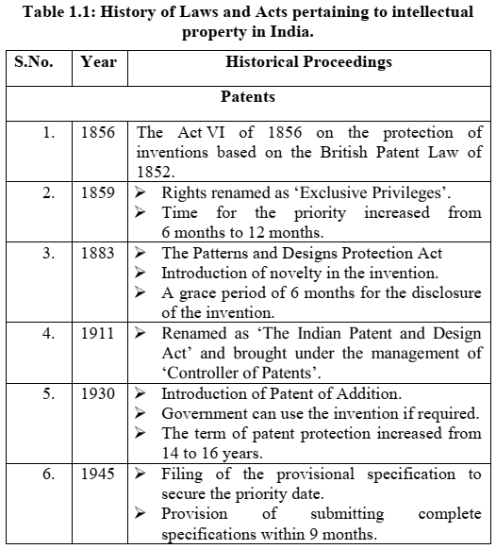

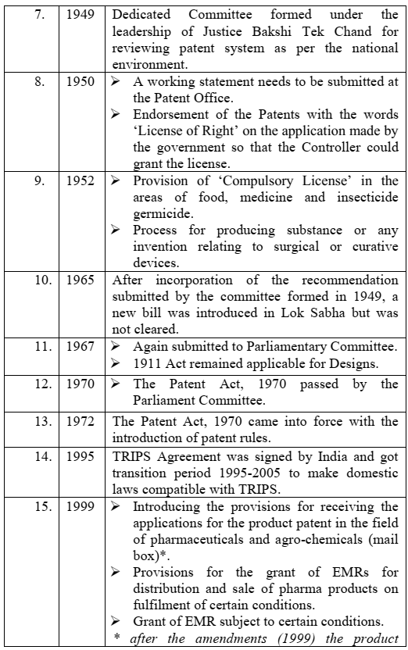

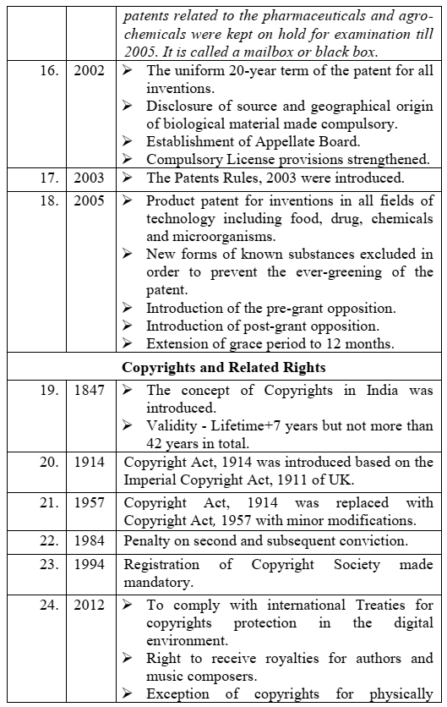

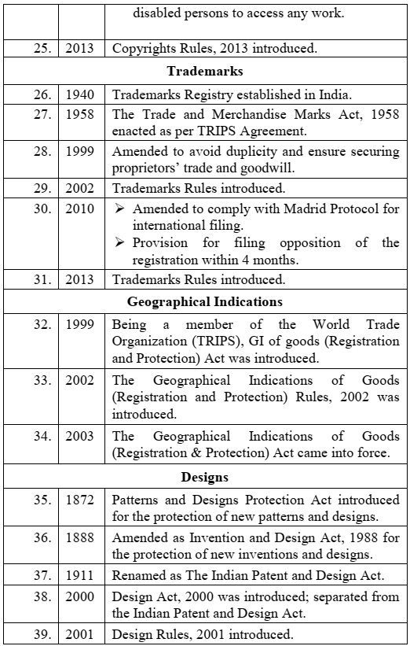

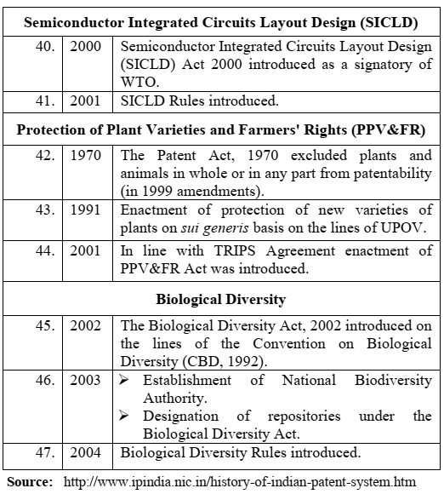

**Patents**

A patent is an exclusive right granted for an innovation that generally provides a new way of doing something or offers a new technical solution to a problem. The exclusive right legally protects the invention from being copied or reproduced by others. In return, the invention must be disclosed in an application in a manner sufficiently clear and complete to enable it to be replicated by a person with an ordinary level of skill in the relevant field.

**Conditions for Obtaining a Patent Protection**

There is a set criterion, as provided in Section 2(1)(j) of the Patents Act, 1970, which must be fulfilled for a product or a process to qualify for the grant of a patent. The criterion encompasses:

* **Novelty** - *Not part of ‘State of the Art’*. The innovation claimed in the patent application is new and not known to anybody in the world. In other words, the innovation is a) not in the knowledge of the public, b) not published anywhere through any means of publication and c) not be claimed in any other specification by any other applicant.
* **Inventive step** - *Not obvious to the person (s) skilled in the art*. The innovation is a) a technical advancement over the existing knowledge, b) possesses economic significance and, c) not obvious to a person skilled in the concerned subject.
* **Capable of industrial application** - *For the benefit of society*. The invention is capable of being made or used in any industry.

**To Patent or Not to Patent an Invention**

Once an invention has been developed, the inventor has to decide whether to exploit the invention for personal benefits as provided by the statutory laws of the country or put it in the public domain. By and large, the inventor prefers the former option. Only a miniscule of inventions are placed in the public domain without claiming any benefits. In the latter case, anybody can exploit the innovation for commercial or societal benefit without paying any money to the inventor If the owner of an invention wishes to seek monetary gains, he can choose from either of the two options, i.e. patenting or Trade Secret. If the inventor is absolutely sure of maintaining the secrecy of invention for a very long period (maybe 100 years or more) and the probability of reverse engineering of the technology is nil or very low, then the ‗Trade Secret‘ category is preferred. If the invention has a short life span or can be kept secret only for a small period of time (a couple of years or so) or the probability of reverse engineering is high once the invention is in the public domain, then the ‘patent‘ category is preferred

**Rights Associated with Patents**

As per the Court of Law, a patent owner has the right to decide who may or may not use the patented invention. In other words, the patent protection provided by the law states that the invention cannot be commercially made, used, distributed, imported, or sold by others without the patent owner's consent. The patent owner may permit other parties to use the invention on mutually agreed terms. As a matter of fact, the patent rights are negative rights as the owner is restricting others from using the patent in any manner without his prior permission. The patent holder may choose to sue the infringing party to stop illegal use of the patent and also ask for compensation for the unauthorized use.

**Enforcement of Patent Rights**

Enforcement is the process of ensuring compliance with laws, regulations, rules, standards and social norms. Patent rights are usually enforced by the judicial courts. The Court of Law has the authority to stop patent infringement. However, the main responsibility for monitoring, identifying and taking action against infringers of a patent lies with the patent owner.

**Inventions Eligible for Patenting**

Patents may be granted for inventions/technologies in any field, ranging from a paper clip or ballpoint pen to a nanotechnology chip or a Harvard mouse (mouse with cancer genes). It is a general belief that patents are awarded only to major scientific breakthroughs. But, it is not true. In fact, the majority of patents are granted to inventions displaying an improvement over the existing invention. For example, many patents can be awarded to a single molecule e.g. penicillins (an antibiotic that kills microbes) and its derivatives. The derivatives are made by making subtle changes in the structure of the penicillin resulting in new/improved properties, such as acid stability or temperature stability or killing a wide range of microbes (germs). The new antibiotic molecules, known as second, third or fourth generation  
penicillins can also be patented.

**What is not an ‘Invention’?**

According to Sec 3 of the Patent Act, 1970

* Frivolous inventions
* Inventions contrary to well established natural laws
* Commercial exploitation or primary use of inventions, which is contrary to public order or morality which causes serious prejudice to health or human, animal, plant life or to the environment
* Mere Discovery of a Scientific Principle or Formulation of an Abstract Theory or
* Discovery of any living thing or
* Discovery of non–living substance occurring in nature
* Mere discovery of any new property or new use for a known substance or of the mere use of a known process, machine or apparatus, unless such known process results in a new product or employs at least one new reactant.
* Substance obtained by mere admixture resulting only in the aggregation of the properties of the components thereof or a process for producing such substance
* Mere arrangement or re-arrangement or duplication of known devices, each functioning independently of one another in a known way Method of Agriculture or Horticulture
* Any process for medicinal, surgical, curative, prophylactic, diagnostic, therapeutic or other treatment of human beings or a similar treatment of animals to render them free of disease or to increase their economic value or that of their products
* Plants & animals in whole or any part thereof other than micro- organisms, but including seeds, varieties an d species and essentially biological process for production or propagation of plants & animals
* mathematical method or business method or algorithms or computer programme per se
* A literary, dramatic, musical or artistic work or any other aesthetic creation including cinematographic work and television productions
* Presentation of information
* Topography of integrated circuits.
* Inventions which are Traditional Knowledge or an aggregation or duplication of known properties of traditionally known component or components.

**What is meant by ‘New”?**

The invention to be patented must not be published in India or elsewhere, or in prior public knowledge or prior public use with in India or claimed before in any specification in India A feature of an invention that involves technical advance as compared to the existing knowledge or have economic significance or both and makes the invention not obvious to a person skilled in the art.

**What can be patented?**

Any invention concerning with composition, construction or manufacture of a substance, of an article or of an apparatus or an industrial type of process.

**What cannot be patented?**

Inventions falling within Section 20(1) of the Atomic Energy Act, 1962 Who are the beneficiaries of the patent grant?

* The inventor is secure from competition and can exploit the invention for his gain.
* For the public the invention becomes public knowledge. The technology is freely available after expiry of patent and cheaper and better products become available.

**Rights Associated with Patents.**

* As per the Court of Law, a patent owner has the right to decide who may or may not use the patented invention.
* In other words, the patent protection provided by the law states that the invention cannot be commercially made, used, distributed, imported, or sold by others without the patent owner's consent.
* The patent owner may permit other parties to use the invention on mutually agreed terms. As a matter of fact, the patent rights are negative rights as the owner is restricting others from using the patent in any manner without his prior permission.
* The patent holder may choose to sue the infringing party to stop illegal use of the patent and also ask for compensation for the unauthorized use.

**Enforcement of Patent Rights. Inventions Eligible for Patenting.**

Enforcement is the process of ensuring compliance with laws, regulations, rules, standards and social norms. Patent rights are usually enforced by the judicial courts. The Court of Law has the authority to stop patent infringement. However, the main responsibility for monitoring, identifying and taking action against infringers of a patent lies with the patent owner

**Non-Patentable Matter.**

In the ‘Patent Act, 1970, there are some exclusions (product and processes) that cannot be patented, such as:

* Invention contrary to public morality - a method for human cloning, a method for gambling.
* Mere discovery - finding a new micro-organism occurring freely in nature, laws of gravity.
* Mere discovery of a new form of a known substance - use of aspirin for heart treatment. Aspirin was patented for reducing fever and mild pains.
* Frivolous invention - dough supplemented with herbs, merely changing the taste of the dough, 100 years calendar, bus timetable.
* Arrangement or rearrangement - an umbrella fitted with a fan, a torch attached to a bucket.
* Inventions falling within Section 20(1) of the Atomic Energy Act, 1962 - inventions relating to compounds of Uranium, Beryllium, Thorium, Plutonium, Radium, Graphite, Lithium and more as notified by the Central Government from time to time.
* Literary, dramatic, musical, artistic work - books, sculptures, drawings, paintings, computer programmes, mathematical calculations, online chatting method, method of teaching, method of learning a language as they are the subject matter of Copyright Act. 1957.
* Topography of integrated circuits - protection of layout designs of integrated circuits is provided separately under the Semiconductor Integrated Circuit Layout Designs Act, 2000.
* Plants and animals - plants and animals in whole or any part including seeds, varieties and species and essentially biological processes for the production or propagation of plants and animals are excluded from the scope of protection under patents.
* Traditional knowledge - an invention which in effect is traditional knowledge or which is an aggregation or duplication of known properties of traditionally known components are also excluded.

**Patent Infringements.**

Once the patent is granted to the applicant, he owns the right to use or exploit the invention in any capacity. If anyone uses the invention without the prior permission of the owner, that act will be considered an infringement of the invention. Infringements can be classified into two categories:

Direct Infringement - when a product is substantially close to any patented product or in a case where the marketing or commercial use of the invention is carried out without the permission of the owner of the invention.

Indirect Infringement - When some amount of deceit or accidental infringement happens without any intention of infringement. If such an unlawful act has been committed, the patentee holds the right to sue the infringer through judicial intervention. Every country has certain laws to deal with such unlawful acts. Following reliefs are made available to the patentee:

* Interlocutory/interim injunction.
* Damages or accounts of profits.
* Permanent injunction.

It is pertinent to mention that the Central government always holds the rights (Section 100 of the Patent Act, 1970, Rule 32 of the Patent Rules, 2003) to use the invention in the case of national emergency or other circumstances of extreme urgency after notifying the owner

**Avoid Public Disclosure of an Invention before Patenting.**

* Generally, an invention that has been either published or publicly displayed cannot be patented, as the claimed invention will lose the ‘Novelty‘ criterion.
* However, under certain circumstances, the Patents Act provides a grace period of 12 months for filing a patent application from the date of its publication in a journal or presentation in a reputed scientific society or exhibition.
* Sometimes, disclosure of an invention before filing a patent application is unavoidable, e.g. selling your invention to a potential investor or a business partner who would like to know complete details of the invention in order to judge its commercial value.
* In such a case, it is advisable to sign a Non-Disclosure Agreement (NDA) or any other confidential agreement to safeguards your interest.

**Process of Patenting:**

In India, the process of grant of a patent is a lengthy procedure that may take anywhere 3-4 years or more. The major steps involved in this process are listed in figure 1.

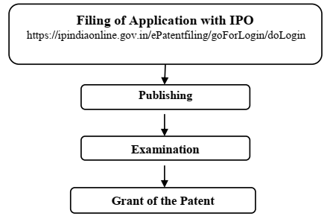

**Figure 1: Flow chart of major steps involved in the grant of a patent.**

**Prior Art Search.**

Before an inventor embarks upon the patent filing process, he has to ensure that his invention is ‗novel‘ as per the criterion for the grant of a patent. For this, he has to check whether or not his invention already exists in the public domain. For this, he needs to read patent documents and Non-Patent Literature (NPL), scientific journals/reports/magazines, etc. The information lying in the public domain in any form, either before the filing of the patent application or the priority date of the patent application claiming the invention, is termed as Prior Art.

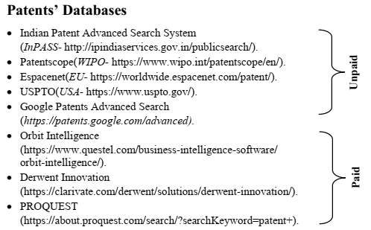

**Choice of Application to be Filed.**

Once a decision has been made to patent the invention, the next step is, what kind of application needs to be filed i.e. provisional patent application or complete (Final) patent application - generally, the provisional patent application is preferred for the following reasons Patent Application Forms.

* It is cheaper, takes less time, and involves fewer formalities.
* Any improvements made in the invention after the filing of the provisional application can be included in the final application. In other words, the provisional application does not require complete specifications of the inventions. The application can be filed even though some data is yet to be collected from pending experiments.
* A provisional application allows you to secure a priority date for the patent applied.

However, it is mandatory to file the complete patent application within one year of the filing of the provisional application; otherwise, the application stands rejected

**Jurisdiction of Filing Patent Application.**

India has four offices for filing patent applications (Table 2.1). The applications can be filed only in one of the offices based on the applicant‘s residence or domicile or place of business or origin of the invention. These are termed as jurisdictions to file patents.

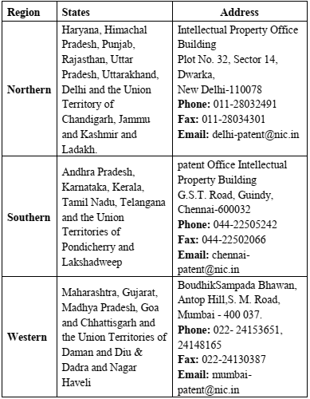

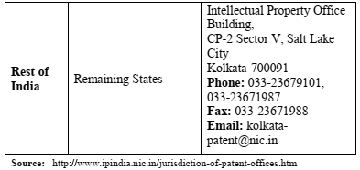

For a foreign applicant, the address for service in India or place of business of his patent agent determines the appropriate Patent Office for filing a patent application. In the case of joint applications, all the applicants are bestowed with equal rights and consideration.

**Publication.**

Once the patent application has been filed at the Regional Patent Office, the patent application is kept secret for 18 months in the Patent Office. After the expiry of 18 months (from the date of filing of the application or the priority claimed date, whichever is earlier), the application is published in the Official Journal of Patent Office (http://www.ipindia.nic.in/journalpatents.htm). The purpose of publishing the application is to inform the public about the invention. The publication of an application is a mandatory step

**Pre-grant Opposition.**

If anybody has an objection to the invention claimed in the patent application, he can challenge the application by approaching the Controller of Patents within 6 months from the date of publication. It is termed as Pre-grant Opposition. Depending on the outcome of the case, the patent application may be rejected or recommended for the next step, i.e. patent examination.

**Examination. Grant of a Patent.**

* Patent examination is a critical step in the process of grant of a patent. All the important criteria (novel, inventive step, etc.) are scrutinized by the professionals depending on the content of the invention.
* Usually, the examiner raises certain queries/doubts which need to be addressed by the inventors.
* Once the examiner is satisfied with the answers received from the inventors, the application is recommended for the grant of a patent.
* It is pertinent to mention that a patent application is not examined automatically after clearing the publication stage.
* The applicant or his representative has to make a request for examination of the patent by filing Form-18A and submitting the same within 48 months from the date of filing of the application.

**Validity of Patent Protection.**

Patent protection is granted to an applicant for a duration of generally 20 years from the application filing date. Following the grant of a patent in India, it is crucial to ensure annual renewal by paying the Patent Renewal Fee as per Section 53, Rule 80 of the Indian Patents Act until the patent's expiration. Failure to make these payments may lead to patent cancellation. It's noteworthy that in certain countries, patent protection can extend beyond the standard 20 years, aiming to compensate for the time spent on administrative approval procedures before products can enter the market. This extension acknowledges that patent owners might not fully benefit from their rights for a considerable period after the patent's initial grant due to procedural delays.

**Post-grant Opposition.**

Once the patent has been granted by the Patent Office, it still can be challenged by anyone within one year from the date of publication of the grant of the patent. The granted patent can be challenged either via a Patent Office or in a Court of Law. These bodies may invalidate or revoke a patent upon a successful challenge by the interested party on the grounds mentioned below:

* The applicant for the patent wrongfully obtained the invention or any part of the invention.
* The invention claimed has been published before the priority date. The invention claimed was publicly known/used before the priority date.
* The invention claimed is obvious and does not involve an inventive step.
* The subject of the claim is not patentable as per Chapter II of the Patent Act, 1970.
* The details/specifications of the invention do not sufficiently and clearly describe the invention.

**Commercialization of a Patent.**

The patent owner may grant permission to an individual/organization/industry to make, use, and sell his patented invention. This takes place according to agreed terms and conditions between the involving parties. A patent owner may grant a license to a third party for the reasons mentioned below:

* The patent owner has a decent job e.g. university professor and has no desire or aptitude to exploit the patent on his own.
* The patent owner may not have the necessary manufacturing facilities.
* The manufacturing facility is not able to meet the market demand.
* The patent owner wishes to concentrate on one geographic market; for other geographical markets, he may choose to license the patent rights.

Once the patent is granted, the patentee (person holding the rights to the patent) enjoys the exclusive rights to use the patented invention. Only the patentee has the right to licence or deal with the patent for any deliberations. Although, the validity of the granted patent is for 20 years (from the date of filing a patent application), but the patentee is required to furnish information (Form-27), on an annual basis relating to the commercialization/selling of the patent.

It is called as ‘**Working/Licensing of the Patent**‘.

The licensing of a patent can be exclusive or non-exclusive. In an **Exclusive Licence**, the patent is sold to only one individual/organization for a fixed time period. During this time period, no other person or entity can exploit the relevant IP except the named licensee. In **Non-Exclusive Licence**, a patentee can sell his patent rights to as many individuals/parties as he likes. If the patentee is not able to commercialize his patent within three years from the date of the grant of a patent, any person may submit an application to the Controller of Patents for grant of

**Compulsory Licensing (of the patent),** subject to the fulfilment of following conditions:

Reasonable requirements of the public concerning the patented invention have not been satisfied.

* The patented invention is not available to the public at a reasonable price.
* The patented invention is not worked in the territory of India.

**Flowchart for the process of filing a patent application.**

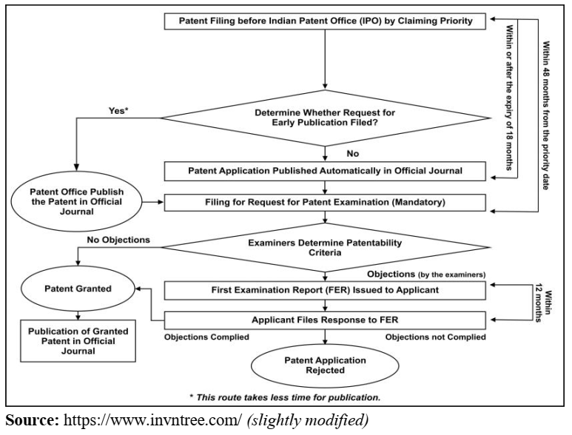

**Need for a Patent Attorney/Agent.**

In general, applicants can prepare their patent applications and file them without assistance from a patent attorney. However, given the complexity of patent documents, it is advisable to seek legal assistance from a patent attorney/agent when drafting a patent application. Furthermore, the legislation of many countries requires that an applicant, whose ordinary residence or principal place of business is outside the country, be represented by an attorney or agent qualified in the country (which usually means an agent or attorney who resides and practices in that country).

**Can a Worldwide Patent be Obtained.**

The concept of a 'Universal Patent,' 'World Patent,' or 'International Patent' does not exist because patent rights are territorial. Patent applications must be filed with the Patent Office of the specific country where protection is sought. However, filing patent applications in numerous countries individually can be arduous, time-consuming, and expensive. To address this challenge, Regional Offices, such as the European Patent Office and the African Regional Intellectual Property Organization, have been established to receive applications on behalf of a group of nations. A single application with these regional offices can provide patent coverage for multiple member nations. Alternatively, for global patent protection, it is advisable to file an international patent under the Patent Cooperation Treaty (PCT), provided the applicant's country is a member of the PCT. India, being a member of the PCT along with over 190 other nations, can utilize this international mechanism for streamlined and comprehensive patent protection.

**Do I Need First to File a Patent in India?**

Yes, in general, Indian residents are required to file the patent application first in India. Subsequently, they may file for patent protection in other countries. But for this, prior approval is needed from the Patent Office. However, this approval can be waived off under the following circumstances:

* The applicant is not an Indian resident.
* If 6 weeks have expired since the patent application was filed in India by an Indian resident.
* If two or more inventors are working on an invention in a foreign country and one of the inventors is an Indian resident.
* The invention does not have a potential market in India and hence does not wish to file the patent in India. In such a scenario, the Indian resident has to seek Foreign Filing Permission (FFP) from an Indian Patent Office.
* In case of international collaboration, if one part of the invention originated in India and the inventor is an Indian resident, he has to seek permission to file the patent outside India.
* If the invention is related to defense or atomic energy or utility model, the inventor/s needs to seek permission from the Indian Patent Office because inventions related to these domains are not the subject matter of patentability in India.

**Patent Related Forms.**

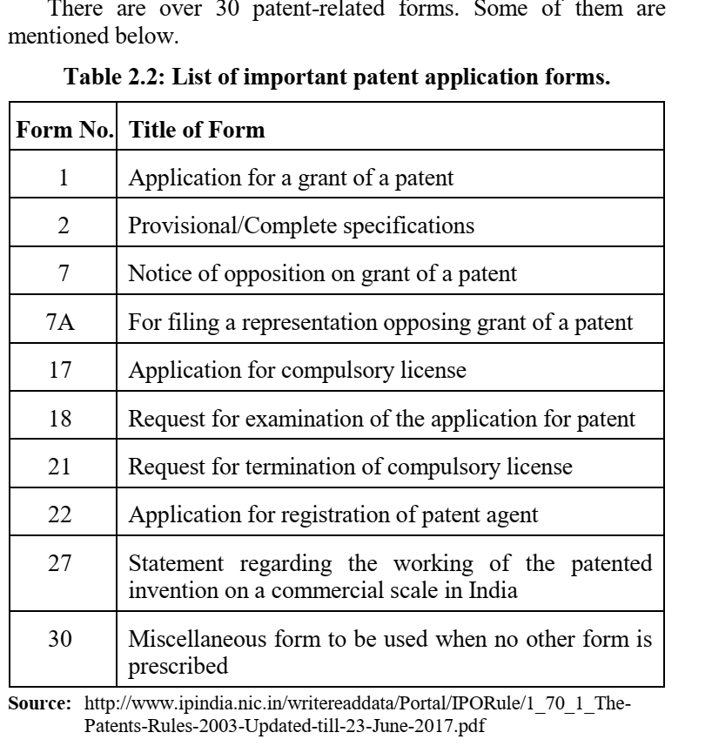

**Fee Structure.**

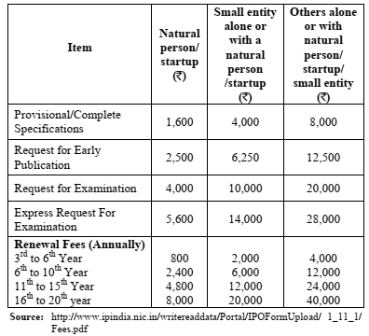

**Types of Patent Applications.**

Provisional Application - A patent application filed when the invention is not fully finalized and some part of the invention is still under experimentation. Such type of application helps to obtain the priority date for the invention.

Ordinary Application - A patent application filed with complete specifications and claims but without claiming any priority date.

PCT Application - An international application filed in accordance with PCT. A single application can be filed to seek patent protection and claim priority in all the member countries of PCT.

Divisional Application - When an application claims more than one invention, the applicant on his own or to meet the official objection on the ground of plurality may divide the application and file two or more applications. This application divided out of the parent one is known as a Divisional Application.

The priority date for all the divisional applications will be the same as that of the main (the Parent) Application (Ante-dating).

Patent of Addition Application - When an invention is a slight modification of the earlier invention for which the patentee has already applied for or has obtained a patent, the applicant can go for ‘Patent of Addition‘, if the modification in the invention is new. Benefit - There is no need to pay a separate renewal fee for the ‘Patent of Addition‘, during the term of the main patent. It expires along with the main patent.

Convention Application - If a patent application has been filed in the Indian Patent Office, and the applicant wishes to file the same invention in the one or more Convention countries (e.g. Paris Convention) by claiming the same priority date on which application was filed in India, such an application is known as Convention Application. The applicant has to file Convention Application within 12 months from the date of filing in India to claim the same priority date

**Commonly Used Terms in Patenting.**

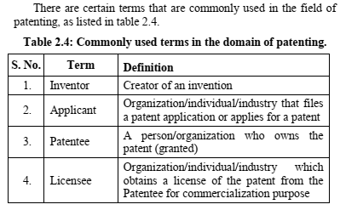

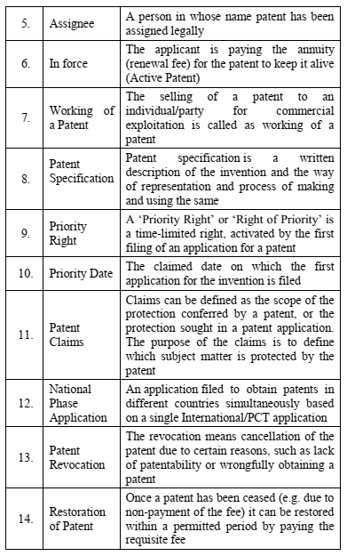

**National Bodies Dealing with Patent Affairs.**

There are many departments/organizations/bodies dealing with various aspects of patents, namely, the Indian Patent Office (IPO), Department for Promotion for Industry and Internal Trade (DPIIT); Technology Information, Forecasting and Assessment Council (TIFAC) and National Research Development Corporation (NRDC).

**Utility Models.**

In many cases, a new invention involves an incremental improvement over the existing products, but this technical improvement is not sufficient enough to pass the stringent criterion of ‘Novelty‘ and ‘Non-obviousness‘ set aside for the grant of a patent. Such small innovations can still be legally protected in some countries and termed as ‘Utility Models’ or ‘Petty Patents’ or ‘Innovation Patents’. In this case, the criterion of ‘Novelty‘ and ‘Non-obviousness‘ are diluted or relinquished. But the requirement of industrial application or utility is the same as that for patents. Utility Model is a helpful tool for Micro, Small and Medium Enterprises (MSME) since the grant of a ‘Utility Model‘ is usually less rigorous and involves minimal cost. MSMEs do not have deep pockets to carry out intensive R&D leading to the grant of patents.

But their innovations are good enough for improving their products/processes and bringing more financial rewards. Such inventions pass the requirements set aside for Utility Models but not for patents. The life of the Utility Model is less as compared to the patents. It varies from 7-15 years in different countries. Nearly 80 countries, including France, Germany, Japan, South Korea, China, Finland, Russian Federation and Spain, provide protection for Utility Models under their IPR laws. India till date does not recognize utility patents. If these small patents are recognised under IP protection in India, it will catapult the number of patents (filed and granted) on annual basis